Church Interpreter vs. AI Translation: What Churches Should Use for Live Services
Church translation provides spoken ministry, announcements, prayers and sermons in languages that people can hear. It is used in churches where there are people from different first languages in one service. A church interpreter can translate speech live, while newer systems produce translated audio and captions through software.

The right choice depends on language needs, budget, theology, AV resources, and service format. This guide compares human interpreters, AI translation, church AV setups, smartphone access, costs or accuracy and livestream options.

What Church Translation Looks Like Today
Multilingual church service could be for immigrants, students, mixed language families and visitors or online viewers. One Sunday might require Spanish. A conference may need several languages at once. Traditional simultaneous interpretation for churches uses a person listening to the speaker and translating live. The interpreter may work from a booth or quiet room. Their microphone feeds a transmitter, which sends audio to dedicated receivers.

Attendees wear church translation headsets connected to those receivers. A wireless translation system for church can work well in one sanctuary. It also creates an equipment workflow involving charging, storage, checkout, sanitizing, and replacement. This model remains useful when doctrine or pastoral sensitivity demands human judgment. Skilled interpreters can recognize humor, cultural references, and biblical phrasing.
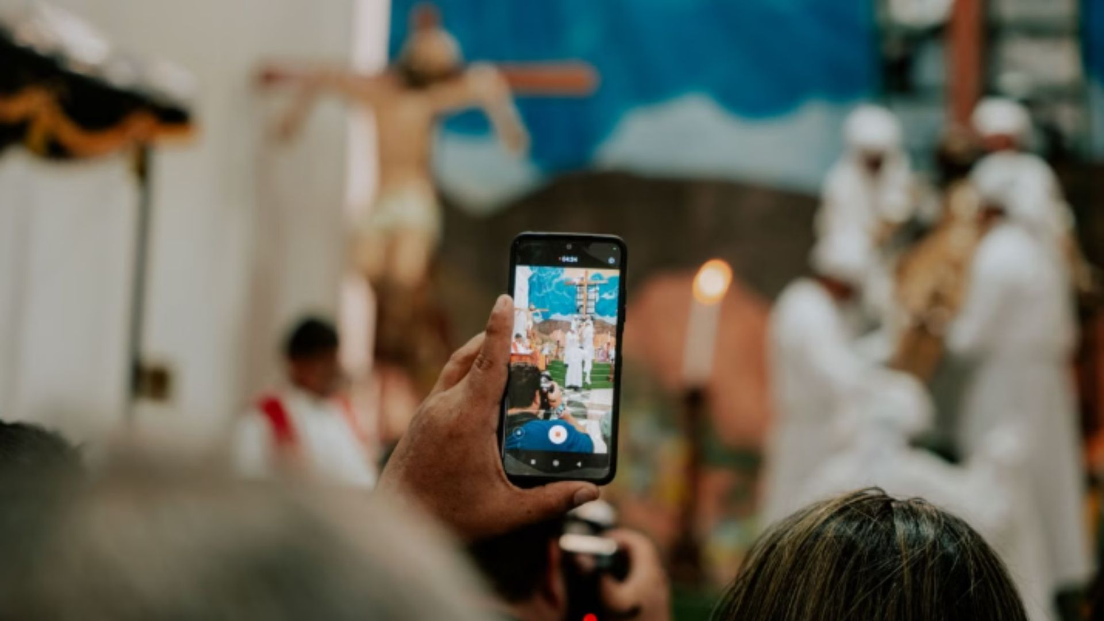

Human Interpreters, Booths, and Translation Hardware
A traditional church interpretation system usually has four parts: an interpreter, microphone, transmitter, and listener receiver. Larger churches may add a booth so interpreters can hear clearly without distracting nearby worshipers. Professional translation equipment for churches can deliver dependable in-room audio without requiring phones.

Church translation equipment requires enough receivers, spare units, charging capacity, and staff. Multiple languages may need additional interpreter channels. A church serving 40 Spanish speakers may issue 40 receivers weekly. Staff must prepare, collect, inspect, and recharge those church translation devices. A church translator benefits from sermon notes, Bible passages, names, and unusual terms before the service.

How AI Church Translation Works
Modern AI translation for churches changes the delivery path. Instead of routing one interpreter into dedicated receivers, software converts the pastor's speech into other languages.

A common workflow looks like this:

- Church microphone or mixer sends a clean speech feed.
- Church translation software transcribes and translates the speech.
- Text-to-speech creates translated audio where supported.
- Listeners receive audio, captions, or both on their devices.

This supports real-time church translation across several languages. Speech-to-speech translation for churches also serves people who prefer audio over reading. Exbabel follows this browser-based model. Attendees join by QR code or web link, choose a language, then receive translated speech and captions.
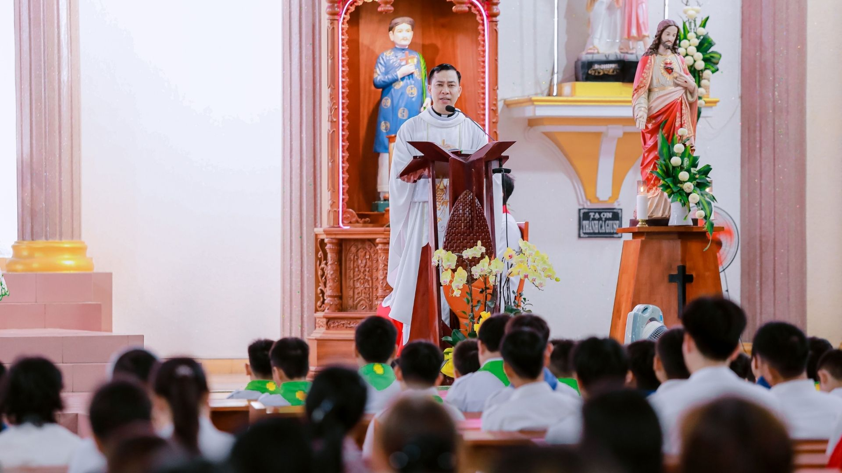

Live Audio, Captions, and Smartphone Access
Live audio translation for churches lets people follow without reading continuously. Translated captions for church services help readers and people with hearing needs. Using both formats gives listeners a choice, especially when names or Scripture references are hard to hear.

Church translation using smartphones removes much of the receiver-handling process. A QR code church translation setup can place codes on seat cards, entrance signs, slides, or printed programs. A listener scans the code, selects Spanish, and connects earbuds. That enables church translation without receivers, or church translation without headsets for caption readers.

At a church conference, the same setup can serve several languages without assigning separate receiver inventories to each audience group. Church translation without special hardware still requires an audio source, internet connection, and computer. Spoken audio also requires listener devices and earbuds. Exbabel says attendees need no app download. It reports roughly two-second translated speech and one-second captions though actual latency can vary.
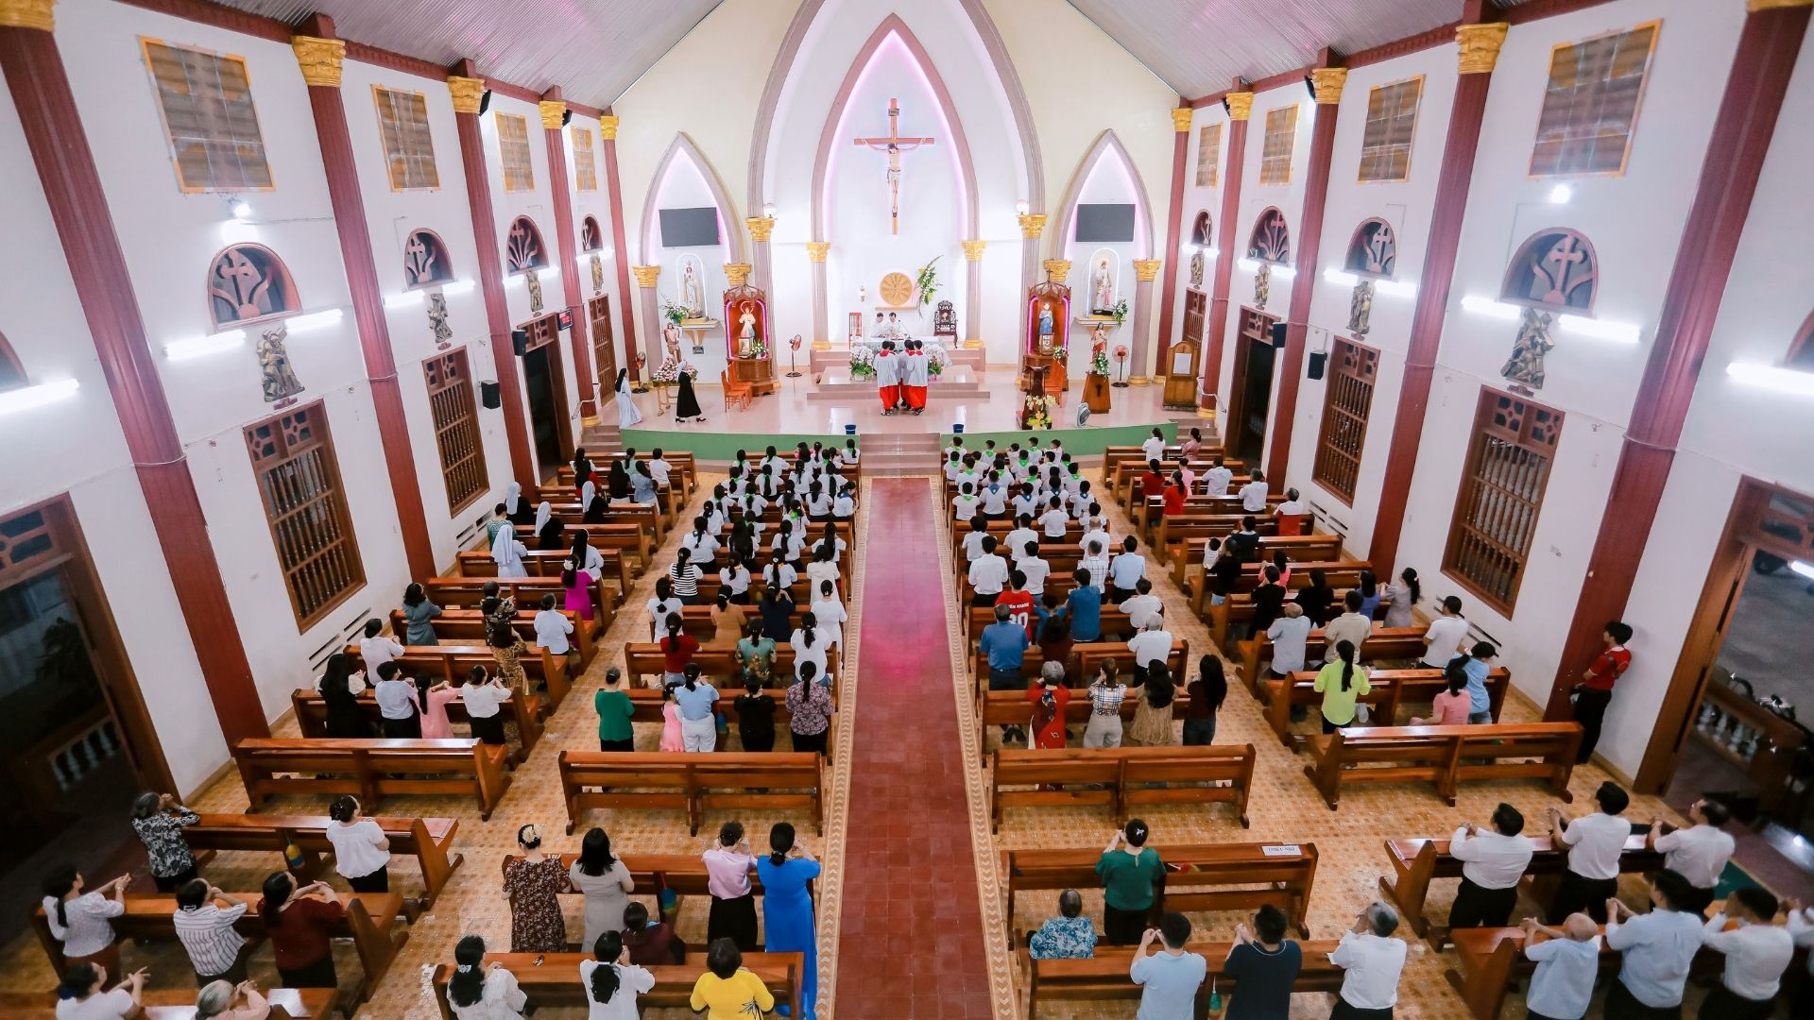

Connecting Translation Software to the Church Sound System
Good translation starts before any language model processes a word. Poor microphone technique, clipping, room echo, and loud music can reduce transcription quality. For church AV translation, send the cleanest practical speech feed from the mixer. A dedicated auxiliary output can isolate the pastor's microphone from drums, audience noise, and room microphones.

A common church mixer translation path is:

Pastor microphone → mixer AUX or bus → USB audio interface → computer/browser → translation platform → listener devices

Smaller churches may use a direct microphone input. Production teams may route livestream audio from an encoder into compatible software. Exbabel documents mixer, browser, and livestream workflows, including QR access for listeners. Before Sunday, test gain, internet stability, language selection, QR access, and listening from the back row.

Translating English Sermons Into Spanish and Other Languages
Spanish church translation is a common starting point for American congregations with Spanish-speaking members. Consider an English service with 25 Spanish-speaking attendees. The AV operator sends the pastor's mixer feed into the platform. Attendees scan a code, choose Spanish, and listen or read.

This supports church translation for Spanish speakers without a second service and can expand into multilingual worship as needs change. For live sermon translation, preparation still matters. Share difficult names, ministry terms, locations, and recurring phrases with interpreters or software glossaries.

Sermon translation becomes harder when the speaker talks quickly, changes direction mid-sentence, or quotes older Bible language. AI sermon translation also faces challenges with wordplay, idioms, and terms carrying specific theological meaning.


AI Translation vs. Human Church Interpreters
The best church translation system is not automatically the newest one. Churches should match the method to the service.

Factor | Human Interpreter | AI Translation
Cultural nuance | Strong with an experienced interpreter | Depends on language, context, and model
Theological judgment | Strong when the interpreter knows doctrine | Needs testing and terminology support
Language expansion | Requires more qualified people | Can add languages through software
Weekly scheduling | Requires interpreter availability | Software can run when configured
Listener hardware | Often uses receivers and headphones | May use personal phones and earbuds
Internet dependence | Can operate on local RF equipment | Cloud systems usually need reliable internet
Captions | Requires separate captioning tools | Often available beside translated audio
Cost structure | Labor plus equipment | Subscription or usage-based software

Human interpreters remain valuable for doctrinal teaching, ceremonies, pastoral messages, and sessions where wording carries unusual weight. AI may suit recurring services needing several languages. A hybrid model can retain an interpreter while software covers additional languages.

Software vs. Traditional Equipment, Costs, and Church Size
A translation system for church should be evaluated by total workload, not purchase price alone. Traditional hardware costs may include transmitters, receivers, charging stations, batteries, headphones, repairs, and replacements.

A church translation app or browser platform shifts spending toward software, internet, and audio integration. Some systems charge subscriptions, service hours, languages, or usage levels.

For a small church, reducing receiver inventory may matter most. Volunteer AV teams also need manageable setup. A megachurch may need multiple campuses, redundant internet, livestream routing, and backups. It may pair church interpretation software with professional interpreters. When comparing pricing, include cost per service, annual operations, interpreter scheduling, and equipment management.


Church Livestream Translation and Theological Accuracy
Church livestream translation extends the same challenge beyond the sanctuary. Online viewers cannot collect an RF receiver at the welcome desk. They need translated audio, captions, or a language link they can open remotely. Exbabel currently describes RTMP workflows for OBS and vMix, plus translated web-player delivery.

Accuracy deserves special attention in worship. “Grace,” “justification,” “sanctification,” and “communion” may carry meanings that ordinary conversational translation misses. Bible book names, verse references, Hebrew or Greek terms, denominational language, and names also cause errors.

Test recurring terminology with fluent members. A clean feed improves recognition. Custom glossaries can help when church translation software supports them. Sensitive teaching may still warrant human review.

How to Choose and Set Up a Church Translation System
Start with the congregation. Count recurring languages, listeners, online viewers, and caption needs.

Then work through these steps:

- Decide which languages need audio, captions, or both.
- Test the pastor's microphone and create a clean mixer feed.
- Compare interpreter availability with software and hardware costs.
- Run a full service rehearsal using real sermon material.
- Test Bible terms, names, accents, music transitions, and fast speech.
- Place QR instructions where visitors can find them easily.
- Keep a fallback plan for internet, device, or audio failures.
- Collect feedback from native speakers after several services.

The strongest setup may be human, AI, or hybrid. Exbabel is one modern option for churches wanting browser-based audio and captions on attendee devices.

FAQs

Question 1. Can AI translate a church service live?
Answer: Yes. Modern systems can transcribe speech, translate it, and deliver audio or captions during the service. Delay and accuracy vary by platform.

Question 2. Do churches still need translation headsets?
Answer: Sometimes. Translation headsets for church remain useful for attendees without smartphones and for controlled RF-based listening environments.

Question 3. Can attendees use their own earbuds?
Answer: Yes, when the chosen platform delivers translated audio to personal phones. This reduces dedicated receiver distribution but requires compatible devices and connectivity.

Question 4. Is AI accurate enough for Bible teaching?
Answer: It can handle many routine sermons, but churches should test theological vocabulary and Scripture references. Human interpretation remains useful when wording requires judgment.

Question 5. What should a church test before launch?
Answer: Test audio quality, network stability, latency, QR access, target languages, captions, Bible terminology, listener volume, and a backup workflow.

Conclusion:
Churches now have more ways to serve people who speak different languages. Human interpreters remain valuable when cultural nuance and theological judgment matter most. AI can help when churches need recurring translation across several languages without managing large receiver inventories.

The right approach depends on congregation size, AV resources, language needs, budget, and service format. Some churches may also benefit from combining both methods. For churches exploring smartphone-based live church translation, Exbabel provides translated audio and captions through listeners’ existing devices. That makes it worth considering alongside interpreters and traditional equipment.

Meta Description: Learn how church translation works for live services, from human interpreters to AI audio, captions, smartphones, and livestreams.

